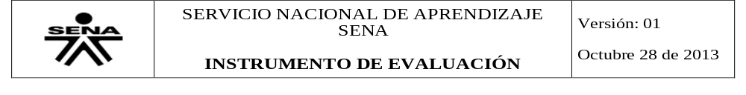
INFORMACIÓN GENERAL
CODIGO PARA IDENTIFICACIÓN DEL INSTRUMENTO: Directions-possessives-present contiuous WORKSHOP
FECHA DE APLICACIÓN: Mach 2019
PROGRAMA DE FORMACIÓN: TECNÓLOGO ADSI
ID: 1804230
CENTRO: PROCESOS INDUSTRIALES Y CONSTRUCCIÓN
CRITERIOS DE EVALUACIÓN:
*Utiliza estructuras aprendidas durante el trimestre.
*Identifica vocabulario específico y escribe textos cortos coherentes.
EVIDENCIA: Desempeño Producto Conocimiento
NOMBRE DEL APRENDIZ: YULY CATHERINE ROJAS ECHEVERRI
NOMBRE DEL INSTRUCTOR- TUTOR: PAOLA NATALIA OROZCO OROZCO

- Complete the conversation with Possessive Adjective
You: Hi
Tom: Hello
You: How are you?
Tom: I’m fine, thanks. How are you?
You: I’m good, thank you. What’s your name?

Tom: I’m Tom, My name is Thomas, but everyone calls me Tom.
You: Are you married?
Tom: Yes. This is my wife.
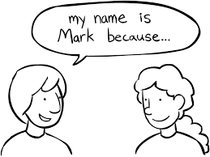
You: What is her name?
Tom: Her name is Karen.
You: Do you have kids?
Tom: Yes. This is my son.
You: What is his name?
Tom: His name is John.
You: Do you have pets?
Tom: Sure. These are my dogs.
You: What are their names?
Tom: Its names are Scooby and Smokey.
And this is my cat.
You: What’s its name?
Tom: Its name is Kitty.
You: Thank you very much.
Tom: You welcome.
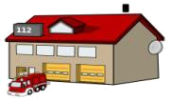
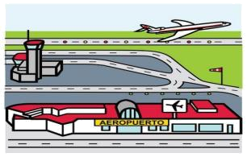
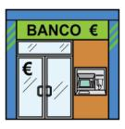
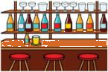
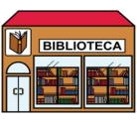
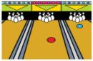
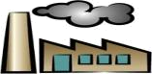
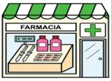
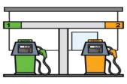
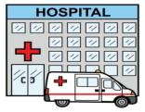
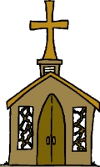
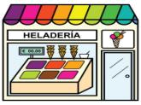
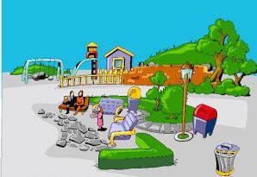
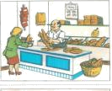
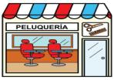
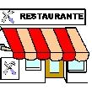
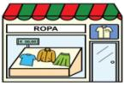
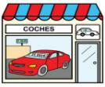
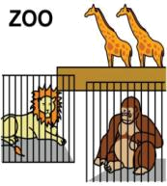
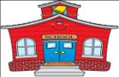
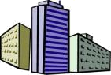
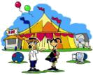
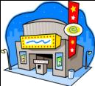
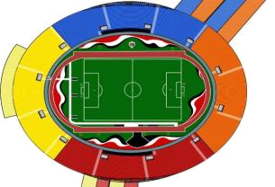
Washington Street
George Street
Stanford Avenue
Jefferson Avenue
Start
CLOTHING STORE
GARAGEE
ICE CREAM PARLOR
LIBRARY
RESTAURANT
BANK
OFFICE BUILDING
DRUGSTORE
BEAUTY PARLOR
A
B
C
D
E
F
G
H
I

DRUGSTORE

Directions:
How can I get to the library? EXAMPLE
Go straight on Stanford Avenue for 2 blocks, then turn left on Washington Street. Go down a block, the library is next to the fire station.
Where’s there a garage near here?
Go on one block and on George Street turn right one block, across until to corner the stadium and the garage is across.

Where’s there a bowling place near here?
Go ahead two block and on Washington Street turn right the bowling place is next to clothing store.

I need to go to a bar.
Go on one block and on George Street turn right one block, turn left and go ahead two block the bar is across the office building.

Do you know where the zoo is?
Go on three block the zoo is across the library

How do I get to the fire station?
Go ahead two block, on Washington Street turn left, the fire station is next to library.

Answer the questions according to the picture:

Where’s the fire station?
It’s on Washington Street, next to the library.
Where’s the school?
It’s on Stanford Avenue in front the library.

Where’s the bank?
It´s on Washington Street Across the circus.

Where’s the church?
It´s on George Street next to ice cream parlor.

Where’s the gas station?
It´s on George Street next to garage.

Where’s the circus?
It´s on Washington Street across the bank.

WRITE 8 DIFFERENT PLACES IN A CITY AND SPANISH MEANING
-MALL: CENTRO COMERCIAL
-GYM: GIMNASIO
-PET SHOP: TIENDA DE MASCOTAS
–ANIMAL REFUGE: REFUGIO ANIMAL
-CEMENTERY: CEMENTERIO
-CONCESSIONAIRE: CONCESIONARIO
-UNIVERSITY: UNIVERIDAD
-BARBER SHOP: PELUQUERIA
-CANDY STORE: DULCERIA

WHAT ARE THEY DOING? USE PRESENT CONTINOUS STRUCTURE
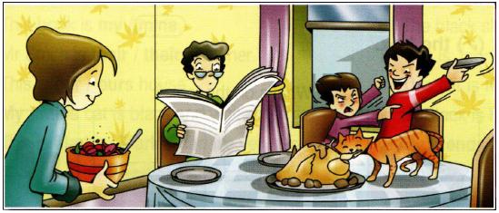

- The father is Reading the newspaper.
- The mother is serving the sald.
- The youngest child is arguing.
- The biggest child is bothering.
- The cat is eating the chiken.

Complete the sentences using presente continous structure. Use the following words in the chart
Wash | Cook | Play | Build | Swim
Snow | Have | Watching | come | do

- Top of Form
1. | I can't talk now. I am washing the dishes.
2. | Listen to Jim. He is playing the guitar.
3. | It snowing so we can go skiing.
4. | Look at Jill. She is swiming in the river.
5. | They are building a new house in Fairfield.
6. | Someone is cooking I can smell the food.
7. | Hurry. The bus is coming
8. | They are doing their exercises so they can lose weight.
9. | I can't answer the phone. I am having a shower.
10. | Don and Jerry are watching the football on TV.

